Creating a Smart Layout for nesting die files
You can use the Smart Layout feature to automatically gang die files for production.
- Select File > Import > Die.
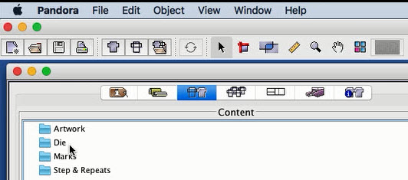
- In the Import Die dialog box, browse to the location of the die file, select the file, and then click Open (Macintosh) or Import (Windows).
- When the die appears in the Die folder on the Content tab of the Information window, drag it to the layout view. If you have already imported a substrate to the layout view, the software will center the die on the substrate.
- From ShopMap, add a substrate.
- In the job properties pane, select SmartLayout for dies.
- Select an item under Die and, in the Parameters section, provide values for Minimum Amount and Artwork Rotation.
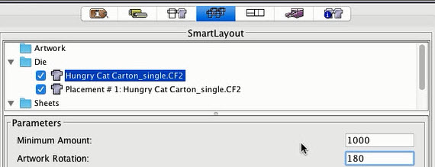
- Select an item under Sheets, and provide values for Fill Direction, Start Corner, and Margins.
Grain direction is dictated by the specified substrate and cannot be modified.
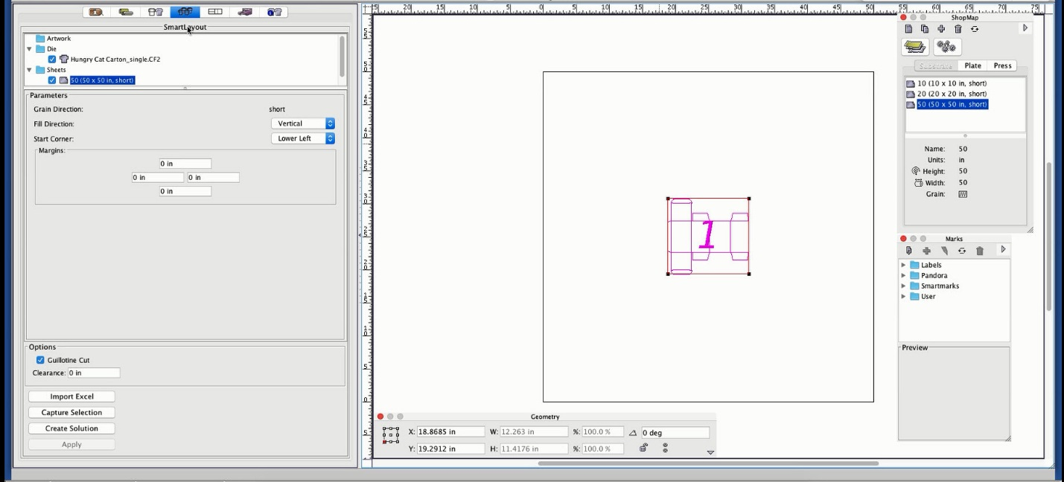
- If desired, select one or more of the Options:
  - Guillotine Cut (align items for the minimum number of cuts in the vertical direction)
  - Clearance (enter a value)
- To view the results of your settings, click Create Solution.
- If desired, change the settings to produce different ganged layouts and click Create Solution to view the results.
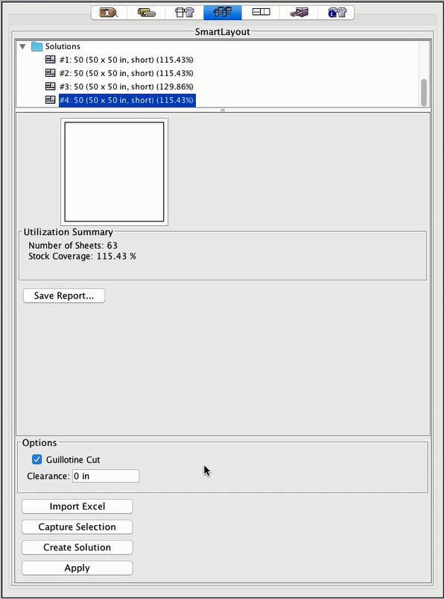
- Optional: To capture a solution without applying the results, click Capture Selection.
- Optional: To generate a job report, click Save Report and specify where to save the .txt file.
- Under Solutions, select the solution that produced the best layout for your purposes.
- Click Apply.

